Security Testing: Identifying Vulnerabilities in AI-Generated Code
NAME:T. ANJALI
ROLL.NO:2503A52410
BATCH-14
Task 1 – Input Validation Check Task:
Analyze an AI-generated Python login script for input validation vulnerabilities.
Instructions:
Prompt AI to generate a simple username-password login program.
Review whether input sanitization and validation are implemented.
Suggest secure improvements (e.g., using re for input validation).
Expected Output:
A secure version of the login script with proper input validation.
PROMPT:
Generate a Python username-password login program.
Check whether username and password inputs are valid.
Use regular expressions to validate the username.
Improve the code with proper input validation.
CODE:
import re

def validate_username(username):
pattern = r"^[a-zA-Z0-9_]{4,15}$"
return re.fullmatch(pattern, username) is not None

def validate_password(password):
return len(password) >= 8

username = input("Enter username: ")
password = input("Enter password: ")

if not validate_username(username):
print("Invalid username!")
elif not validate_password(password):
print("Password must contain at least 8 characters!")
else:
print("Login input validation successful!")
OUTPUT:
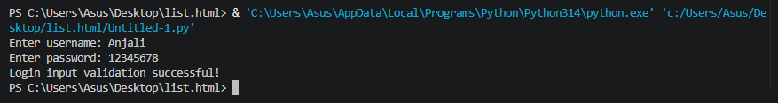
Task 2 – SQL Injection Prevention Task: Test an AI-generated script that performs SQL queries on a database.
Instructions:
Ask AI to generate a Python script using SQLite/MySQL to fetch user details.
Identify if the code is vulnerable to SQL injection (e.g., using string concatenation in queries).
Refactor using parameterized queries (prepared statements).
Expected Output:
A secure database query script resistant to SQL injection.
PROMPT:
Generate a Python SQLite program to fetch user details.
Identify SQL injection risks in the database query.
Use parameterized queries instead of string concatenation.
Provide a secure and corrected version.
CODE:
import sqlite3

conn = sqlite3.connect("users.db")
cursor = conn.cursor()

cursor.execute("""
CREATE TABLE IF NOT EXISTS users (
id INTEGER PRIMARY KEY,
username TEXT,
email TEXT
)
""")

cursor.execute(
"INSERT INTO users (username, email) VALUES (?, ?)",
("Mani123", "mani@example.com")
)
conn.commit()

username = input("Enter username: ")

# Secure parameterized query
cursor.execute(
"SELECT * FROM users WHERE username = ?",
(username,)
)

result = cursor.fetchone()

if result:
print("User Details:", result)
else:
print("User not found")

conn.close()
OUTPUT:
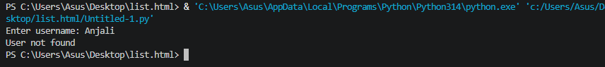
Task 3 – Cross-Site Scripting (XSS) Check Task:
Evaluate an AI-generated HTML form with JavaScript for XSS vulnerabilities.
Instructions:
Ask AI to generate a feedback form with JavaScript-based output.
Test whether untrusted inputs are directly rendered without escaping.
Implement secure measures (e.g., escaping HTML entities, using CSP).
Expected Output:
A secure form that prevents XSS atta
PROMPT:
Generate an HTML feedback form using JavaScript.
Display user feedback on the webpage.
Identify possible XSS vulnerabilities in the code.
Prevent XSS using textContent and secure coding practices.
CODE:
<!DOCTYPE html>
<html>
<head>
<title>Feedback Form</title>

<meta http-equiv="Content-Security-Policy"
content="default-src 'self'; script-src 'unsafe-inline';">
</head>
<body>

<h2>Feedback Form</h2>

<input type="text" id="feedback"
placeholder="Enter feedback">

<button onclick="submitFeedback()">Submit</button>

<h3>Your Feedback:</h3>
<p id="output"></p>

<script>
function submitFeedback() {
let feedback =
document.getElementById("feedback").value;

document.getElementById("output").textContent =
feedback;
}
</script>

</body>
</html>
OUTPUT:


Task 4 – Real-Time Application:
Security Audit of AI-Generated Code Scenario: Students pick an AI-generated project snippet (e.g., login form, API integration, or file upload).
Instructions:
Perform a security audit to detect possible vulnerabilities.
Prompt AI to suggest secure coding practices to fix issues.
Compare insecure vs secure versions side by side. Expected Output:
A security-audited code snippet with documented vulnerabilities and fixes.
PROMPT:
Generate a Python application that fetches user details from SQLite.
Perform a security audit and identify possible vulnerabilities.
Suggest secure coding practices to fix the issues.
Compare the insecure and secure versions of the code.
CODE:
import sqlite3
import re

conn = sqlite3.connect("users.db")
cursor = conn.cursor()

cursor.execute("""
CREATE TABLE IF NOT EXISTS users (
id INTEGER PRIMARY KEY,
username TEXT,
email TEXT
)
""")

cursor.execute(
"INSERT INTO users (username, email) VALUES (?, ?)",
("Mani123", "mani@example.com")
)
conn.commit()

username = input("Enter username: ")

# Input validation
if re.fullmatch(r"[A-Za-z0-9_]{4,15}", username):

# Secure SQL query
cursor.execute(
"SELECT * FROM users WHERE username = ?",
(username,)
)

result = cursor.fetchall()
print("User Details:", result)

else:
print("Invalid username!")

conn.close()
OUTPUT:

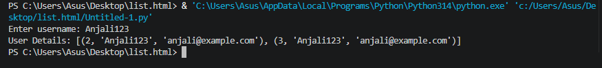
Task 5 – Insecure Data Serialization Check Task: Evaluate AI-generated code that uses pickle for saving user data.
Instructions:
Ask AI to generate a script using pickle.load().
Explain why untrusted pickle data is dangerous. • Replace with safer formats like JSON.
Expected Output:
Secure serialization code using JSON instead of pickle.
PROMPT:
Generate a Python program to save and load student data using pickle.
Identify the security risks of using pickle.load().
Replace pickle with JSON serialization.
Provide a secure version of the program.
CODE:
import json

student = {
"name": "Mani",
"roll_no": "2503A52388",
"branch": "AIML"
}

# Save data using JSON
with open("student.json", "w") as file:
json.dump(student, file, indent=4)

print("Data saved successfully!")

# Load data using JSON
with open("student.json", "r") as file:
data = json.load(file)

print("Student Details:")
print(data)
OUTPUT:


